**MANUSCRIPTS TITLE** |Arial 12|

First Author1, Second Author2*, Third Author1 |Arial 10|

|  |
| --- |
| *1Author Affiliation, Department/Faculty/Unit*  *Organization/Institution Address, City, Postcode, COUNTRY |*Arial 10| |
| *2Author Affiliation, Department/Faculty/Unit Organization/Institution Address, City, Postcode, COUNTRY |*Arial 10| |

**Published online:** ….. |Arial 10|

**To cite this article:** ….. |Arial 10|

**To link to this article**: <https://doi.org/> |Arial 10|

**ABSTRACT** |Arial 12|

1. **Font type: Arial**, *Italic*
2. **Font size:** 10
3. **Alignment:** Justify text
4. **Line spacing:** 1.15
5. **Total words:** 150-200 words

**\*** If the manuscript is fully written in Malay the abstract must be in Malay and English Language.

**Keywords:** Keyword 1, keyword 2, number of keywords is usually 3-5.

INTRODUCTION |Arial 12| (Section Headings)

*The journal welcomes manuscripts between 5000 and 8000 words written in either English or Malay.

The manuscript **MUST** be using Arial with font with **font size 11, alignment justified with 1.15 line spacing and 1 single spacing throughout.** The manuscript should be submitted in **MS Word Format.**

The first paragraph for each title should begin on the left-hand side. For the subsequent paragraph, the beginning of the sentence should be spaced 12.7 mm from the left margin (to be tab 1 time).

**Example:**

The advent of the internet as a new form of media has always been seen to alienate andsideline the role of the conventional media particularly the television.

Statistics of television ownership in the world is expected to

increase….

1. **Sub Section Headings** |Arial 12|
   1. **Sub Section Headings** |Sub Topic 3 Style|

**LITERATURE REVIEW** |ARIAL 12|

*This section should be completed with previous research findings to support the manuscript. The research findings should be within 5 years period, except for certain references.

**RESEARCH METHODOLOGY** |ARIAL 12|

*This section should include the following items:

|  |  |  |  |
| --- | --- | --- | --- |
| i | Introduction | ii | Research Design |
| iii | Research Implementation  Period | iv | Research Population and  Sampling |
| v | Instrumentation | vi | Data Collection |
| vii | Data Analysis |  |  |

**RESEARCH FINDINGS** |ARIAL 12|

*This section should include the findings as per the objective and research question discussed. Your research findings should also include the previous research results/ findings.

**DISCUSSION** |ARIAL 12|

*This section explains thoroughly the research findings discussed critically. It should be also supported with references and justifications.

**Conclusion, Implication and Suggestion** |Arial 12|

*To conclude on the findings and to give suggestions to other interested parties.

**Acknowledgement** |Arial 12|

Example: Thanks to respondents who were directly involved in this study and cooperated throughout the study. Appreciation is also due to the full funding of the study under the grant (LRGS xxx) and approval to conduct research from xxxx Research Ethics Authority.

**Author Contribution** |Arial 12|

Example: The authors confirm contribution to the paper as follows: study conception and design: Author X, Author Y; data collection: Author Y; analysis and interpretation of results: Author X, Author Y, Author Z; draft manuscript preparation: Author Y, Author Z. All authors reviewed the results and approved the final version of the manuscript.

**Reference** |Arial 12|

This section should indicate the source of references for the manuscripts writing. All references should be outlined according to the **American Psychological Association (APA) Style.**

**NOTE**: When formatting your references, please follow the **APA- reference style**(7th edition) (refer to the examples). Ensure that the references are strictly in the journal’s prescribed style, failing which your article will **not be accepted for peer-review**. You may refer to the *Publication Manual of the American Psychological Association* (https://apastyle.apa.org/) for further details.

**Table** |Arial 12|

All tables should be numbered and should have a caption. Headings should be placed above tables.

**Table 1** *xxxxxxxx* |Arial 10|

|  |  |  |
| --- | --- | --- |
| Item |Arial 10| | xxx 1 (%) | xxx 2 (%) |
| xxxxxx | 0 | 0 |
| xxxxxx | 0 | 0 |

|  |  |  |
| --- | --- | --- |
| xxxxxxx | 0 | 0 |

**Figures** |Arial 12|

All figures should be numbered and should have a caption. Headings should be placed below figures.

**(a)XXXX** |Arial 10|

Fig. 1 *Figure description* |Italic, Arial 10|

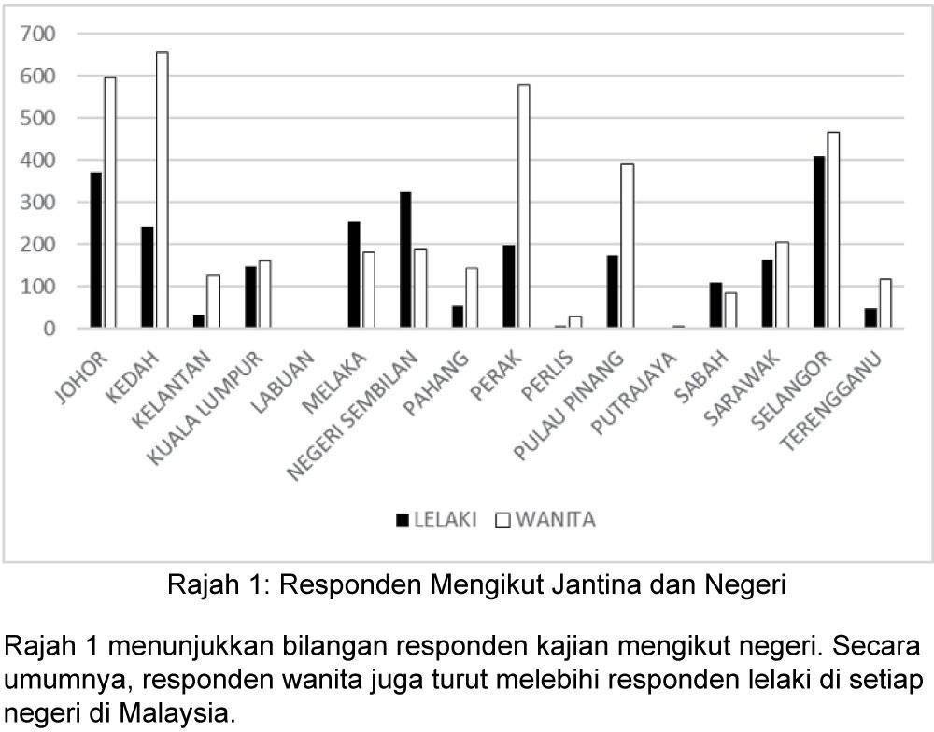

**Fig. 2** *Respondents According to Gender and State* |Arial 10|

Figure 2, indicates the number of research respondents according tostates. In general, the female respondents exceed the male respondents in each state in Malaysia.

Example: **Books**

|  |  |  |
| --- | --- | --- |
| **Books** | **Insertion in Text** | **In Reference List** |
| Book/ e- Book with 1  to 2 authors | **Parenthetical citation:**  … (Nunally, 1978) | Nunally, J.C. (1978). *Psychometric theory*. New York: McGraw Hill. |
| … (Strunk & White, 1979)  … (Gregory & Parry, 2006) | Strunk, W., Jr., & White, E. B. (1979). *The guide to everything and then some more stuff*. New York, NY: Macmillan. |
| Or  **Narative citation:** | Gregory, G., & Parry, T. (2006). *Designing brain-compatible learning (3rd ed.).* Thousand Oaks,  CA: Corwin. |
| Nunally (1978) … |
| Strunk and White (1979)  … |  |
| Gregory and Parry (2006) … |  |
| Book/ e- Book with 3  to 20 authors | For all in-text references, listonly the first author’s family name and followed by ‘et al.’ | Hektner, J.M., Schmidt, J.A. & Csikzentmihalyi, M. (2007). *Experience sampling method: Measuring the quality of everydaylife.* United State: Sage Publications, Inc. |
| **Parenthetical citation:** |
| … (Hektner et al., 1978) |
| Or |
| **Narrative citation:** |
| Hektner et al. (1978) … |
| Chapter in book | **Parenthetical citation:** | Bergquist, J. M. (1992). German Americans. In J. D. Buenker & L.  A. Ratner (Eds.), *Multiculturalism in* |
| … (Bergquist, 1978) … |
| … (Aron et al., 2019) … |

|  |  |  |
| --- | --- | --- |
|  | Or | *the United States: A comparative guide toacculturation and ethnicity* (pp. 53- 76). New York, NY: Greenwood.  Aron, L., Botella, M., & Lubart, T. (2019). Culinary arts: Talent and |
| **Narrative citation** |
| Bergquist (1978) … |

|  |  |  |
| --- | --- | --- |
|  | Aron et al. (2019) … | their development. In R. F. Subotnik, P. Olszewski-Kubilius, &F.C. Worrell (Eds.), *The psychology of high performance: Developing human potential into domain-specific talent* (pp. 345– 359). American Psychological Association. https://doi.org/10.10 37/0000120-016 |
| With Editor | **Parenthetical citation:** | Watson, J. B., & Rayner, R. (2013*). Conditioned emotional reactions: The case of Little Albert* (D. Webb, Ed.). CreateSpace Independent Publishing Platform. <http://a.co/06Se6Na> (Original work published 1920) |
| … (Watson & Rayner, 1920/2013) … |
| Or |
| **Narrative citation:** |
| Watson and Rayner (1920/2013)  … |

**Journal**

|  |  |  |
| --- | --- | --- |
| **Journals** | **Insertion in Text** | **In Reference List** |
| Journal article (with DOI number) | **Parenthetical citation:**  … (Paivio, 1978) … | Paivio, A. (1975). Perceptual comparisons through the mind'seye. *Memory & Cognition*, 3,635- 647.doi:10.1037/0278-  6133.24.2.225 |
| Or |
| **Narative citation:** |
| Paivio (1975) … |

|  |  |  |
| --- | --- | --- |
| Journal article (without DOI number) | **Parenthetical citation:**  … (Becker &  Seligman,1981)  … | Becker, L. J., & Seligman, C. (1981). Welcome to the energy crisis. *Journal of Social Issues*, 37(2), 1-  7. |
| Or |
| **Narative citation:** |
| Becker and Seligman (1981) |

|  |  |  |
| --- | --- | --- |
| Journal article withan article number | **Parenthetical citation:**  … (Jerrentrup et al., 2018) …Or  **Narative citation:** | Jerrentrup, A., Mueller, T., Glowalla, U., Herder, M., Henrichs, N., Neubauer, A., & Schaefer, J. R. (2018). Teaching medicine with the help of “Dr. House.” *PLoS ONE*, 13(3).https://doi.org/10.1371/journal.p one.0193972. |
| Jerrentrup et al. (2018)  … | **Note:** |
|  | If the journal article has an article number instead of a page range, includethe word “Article” and then the article number instead of the page  range. |
| Journal article withmissing information | **Parenthetical citation:**  … (Stegmeir, 2016) … | **Missing volume number:**  Stegmeir, M. (2016). Climate change: New discipline practices promote college access. *The Journal of College Admission*, (231), 44–  47. https:/[/www.nxtbook.com/ygsr](http://www.nxtbook.com/ygsr) eprints/NACAC/nacac_jca_spring2 016/#/46  **Missing issue number:**  Sanchiz, M., Chevalier, A., & Amadieu,  F. (2017). How do older and young adults start searching forinformation? |
| … (Sanchiz et al., 2017)  … |
| … (Butler, 2017) … |
| Or |
| **Narative citation:** |
| Stegmeir (2016) … |

|  |  |
| --- | --- |
| Sanchiz et al. (2017) … | Impact of age, domainknowledge and problem complexity on the different steps of information searching. *Computers in HumanBehavior*, 72,67–  78. https://doi.org/10.1016/j.chb.20  17.02.038  **Missing page or article number:**  Butler, J. (2017). Where access meets multimodality: The case of ASL music videos. *Kairos: A Journal of Rhetoric, Technology, and Pedagogy*, 21(1). [http://technorheto](http://technorheto/)ric.net/21.1/topoi/but ler/index.html |
| Butler (2017) |

**Newspapers**

|  |  |  |
| --- | --- | --- |
| **Newspaper** | **Insertion in Text** | **In Reference List** |
| Newspaper article | **Parenthetical citation:**  … (Carey, 2019) …  … (Harlan, 2013) … | Carey, B. (2019, March 22). Can we get better at forgetting? *The NewYork Times*. https:/[/www.nytimes.com/2](http://www.nytimes.com/2) 019/03/22/health/memory-  forgetting-psychology.html |
| … (Stobbe, 2020) … | Harlan, C. (2013, April 2). North Korea vows to restart shuttered nuclear reactor that can make bomb-grade plutonium. *The Washington Post*, A1, A4. |
| Or  **Narative citation:** |
| Carey (2019) … | Stobbe, M. (2020, January 8). Cancerdeath rate in U.S. sees largest one-year drop ever. *Chicago Tribune*. |
| Harlan (2013) … |
| Stobbe (2020) … |
| Comment onan online newspaper article | **Parenthetical citation:**  … sidneyf (2020)… | sidneyf. (2020, October 7). Oh, I don’t know; perhaps the common-sense conclusion that packing people together — for hours — like sardines |

|  |  |
| --- | --- |
| Or | — may be an [Comment onthe article “When will it be safe to travel again?”]. *The Washington Post*. https://wapo.st/3757UlS |
| **Narative citation:** |
| sidneyf (2020… |  |

**Conference**

|  |  |  |
| --- | --- | --- |
| **Conference** | **Insertion in Text** | **In Reference List** |
| Conference presentation | **Parenthetical citation:** | Evans, A. C., Jr., Garbarino,J., Bocanegra, E., Kinscherff, R. T., & Márquez-Greene, N. (2019, August8– 11). *Gun violence: An event on thepower of community* [Conference presentation]. APA 2019 Convention, Chicago, IL, United States. https://convention.apa.org/2 019-video |
|  | … (Evans et al.,  2019)… |
| Or |
| **Narative citation:** |
| Evans et al. (2019)… |
| Abstract of a conference presentation | **Parenthetical citation:**  … (Cacioppo, 2019) … | Cacioppo, S. (2019, April 25– 28). *Evolutionary theory of social connections: Past, present, andfuture* [Conference presentation abstract]. Ninety-ninth annual convention of the Western Psychological Association, Pasadena,CA, United States. https://westernpsych.org/wp  -content/uploads/2019/04/WPA- Program-2019-Final-2.pdf |
| Or |
| **Narative citation:** |
| Cacioppo (2019)… |
| Conference Proceedings Published in a Journal | **Parenthetical citation:**  … (Duckworth et al., 2019) … | Duckworth, A. L., Quirk, A., Gallop, R., Hoyle, R. H., Kelly, D. R., & Matthews,  M. D. (2019). Cognitive and noncognitive predictors of success. *Proceedings of the National Academyof Sciences, USA*, 116(47), 2349923504.https://doi.org/10.1073/p nas.1910510116 |
| Or |
| **Narative citation:** |
| Duckworth et al. (2019)  … |

|  |  |  |
| --- | --- | --- |
| Conference Proceedings Published as a whole book | **Parenthetical citation:**  … (Kushilevitz &  Malkin,2016)… | Kushilevitz, E., & Malkin, T. (Eds.). (2016). *Lecture notes in computer science:Vol. 9562. Theory of cryptography*.Springer. https://doi. org/10.1007/978-3-662-49096-9 |
| Or |
| **Narative citation:** |
| Kushilevitz and Malkin (2016) |
| Conference Proceedings Published asa book chapter | **Parenthetical citation:**  … (Bedenel et al., 2019) …Or | Bedenel, A.-L., Jourdan, L., & Biernacki, C. (2019). Probability estimation by an adapted genetic algorithm in web insurance. In R. Battiti, M. Brunato, I. Kotsireas, &P. Pardalos (Eds.), *Lecture notes in computerscience Vol.11353. Learning and intelligent optimization* (pp.225– 240).Springer.  https://doi.org/10.1007/9 78-3-030- 05348-2_21 |
| **Narative citation:** |
| Bedenel et al. (2019) … |